# Pitfalls of Macros

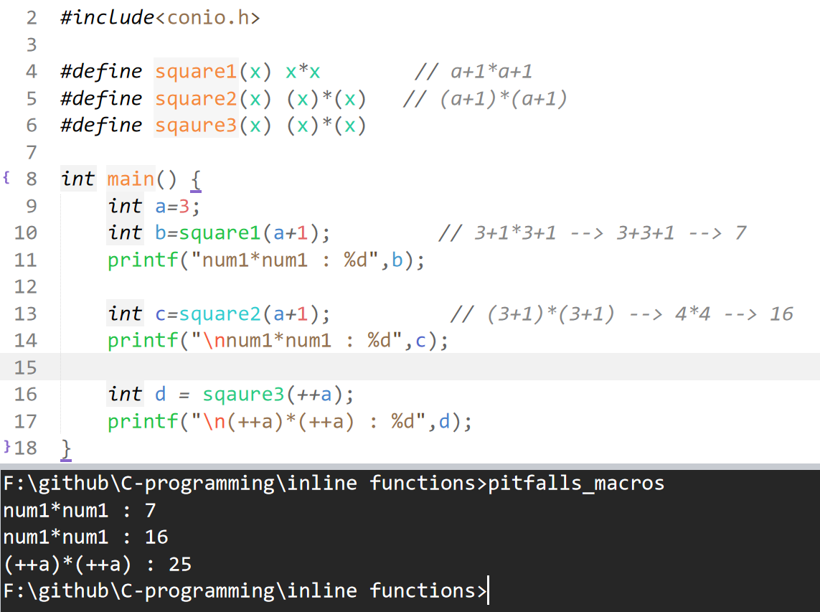

# **Inline over macros**

At the place of function call, we will put the body of that function 🡪 inline

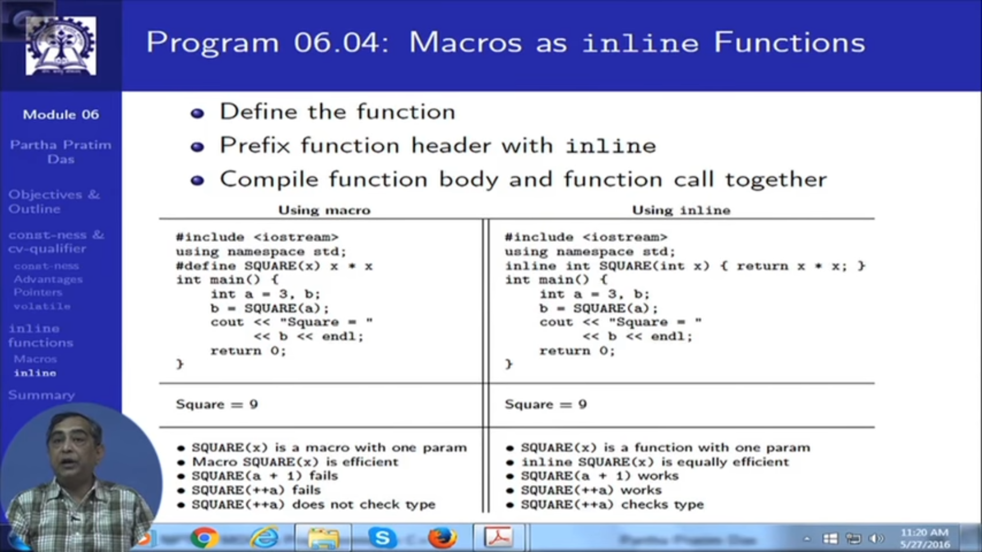

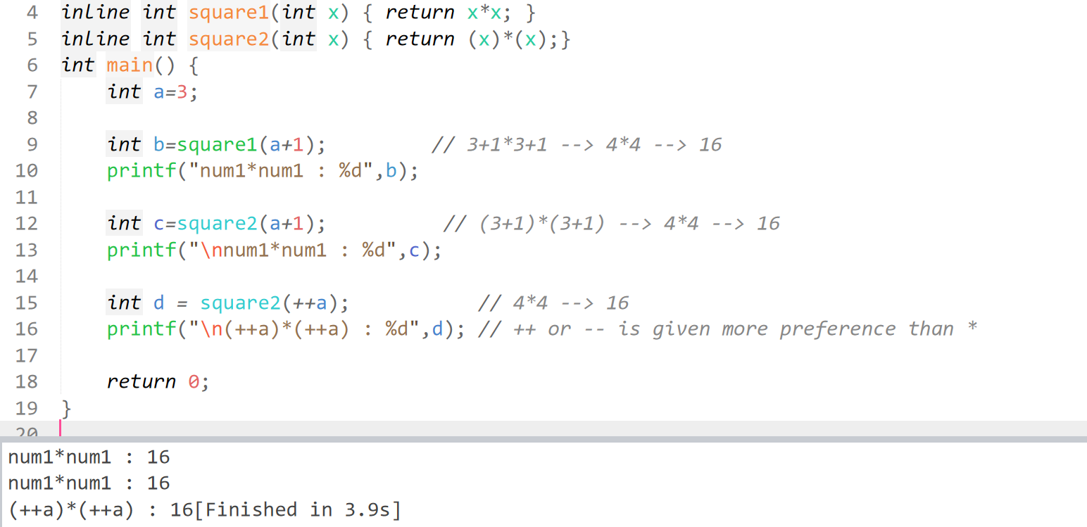

# **Macros vs Inline**

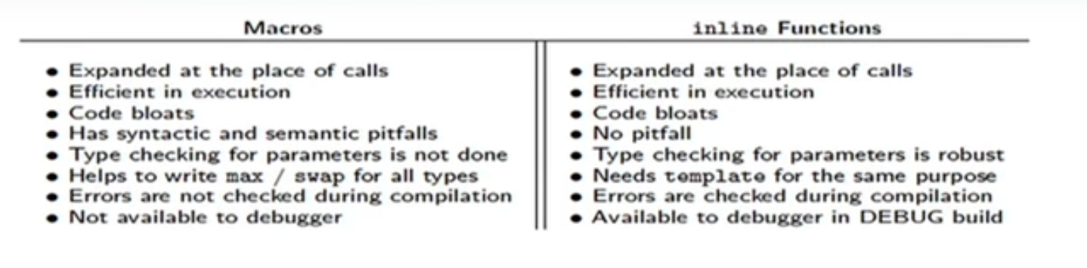

# **Limitations of function Inline**

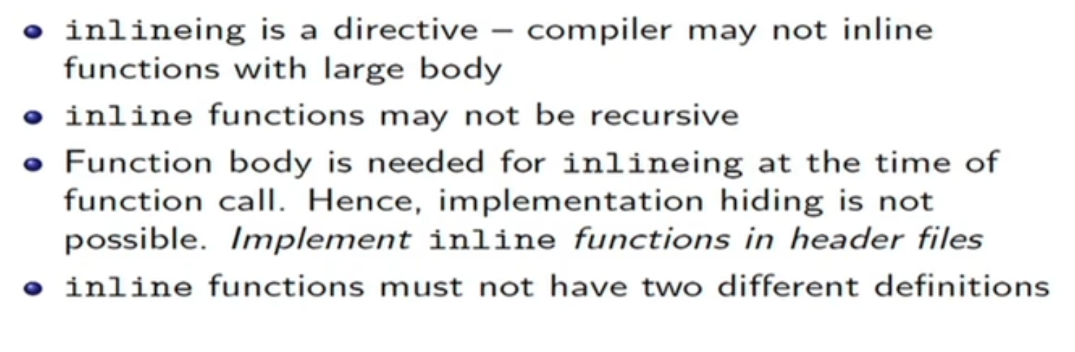

Once if we specify the function as inline, compiler may/may not take that function as inline. According to the size, the compiler will decide.  
Similarly, if we didn’t specify the function as inline, compiler may/may not take that function as a normal function. According to the size, the compiler will decide.  
Generally smaller size function can be treated as inline by the compiler and larger function as a normal function.